Getting Started; User Basics

Lesson 1: Learning how to access & login to your workspace

*Lesson 1 Overview*

* *You will learn how to access & login to your D’Harris Tours customer space.*

### Why should you consider using Firefox web browser to access our website?

It’s free! Since your online business space resides online, you will access our software using most internet ready computer or mobile device. It will help you run our software smoothly. *We suggest you use Mozilla Firefox 5+, Google Chrome or Safari for your browser in order to enjoy the full functionality of your Simple Application.*

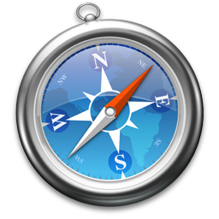

Safari

<http://www.apple.com/safari/download/>



Google Chrome

<http://www.google.com/chrome>



Mozilla Firefox

<http://www.mozilla.org/en-US/firefox/new/>

### Accessing the website

Type into the URL🡪 <http://dharristours.simpsf.com>

If you entered the correct URL once the page has loaded, you will see a login screen like this:

### 

**Type🡪**[**http://dharristours.simpsf.com**](http://dharristours.simpsf.com)

**Hit Enter**

**Now Login!**

### Logging into your Simple Workspace

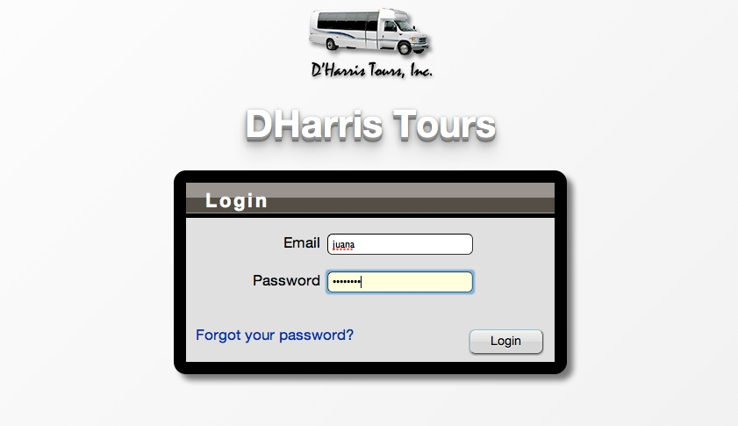

**1st Login using your business e-mail**

**2nd Enter Password – Your temporary password will be Simple1**

### Use your email address and password to login.

To use your Simple Workspace you will need to login to the system. When you first arrive at the Simple application you will are presented with a form asking for your email address and password.In order to access the Customer workspace for the first time you must contact Juana/ D’Harrs Tours and ask to have an account set up. If you don’t have an e-mail/password then you would have to request getting an account set up with Juana from D’Harris Tours

Login using your business email address and temporary password, which will be “simple1”.

### If you forgot the password to your “User Workspace”

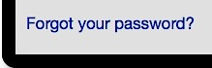Click on the link *“Forgot your password?”* The link will guide you through the necessary steps to retrieve your correct password.

### Section 2: Basic fundamentals of navigating the customer space

**Lesson 2: Left Navigate Pane “101”**

*Lesson 2 Overview*

* *You will gain an understanding of* ***the basic*** *fundamentals of navigating your workspace.*
* *You will learn how to locate and use the “Left Navigation Pane”.*
  + *How to request, view, and edit quotes.*
  + *How to view or request a job.*
  + *How to keep track of Invoices from our company for the job done.*
  + *You will also learn how to “Report a problem*

We will now explore the different components of the screen shot in below***.***

**After logging in, you will see your customer User Space. There are many parts that make up your Workspace. We will go over these in detail but here is a quick reference:**

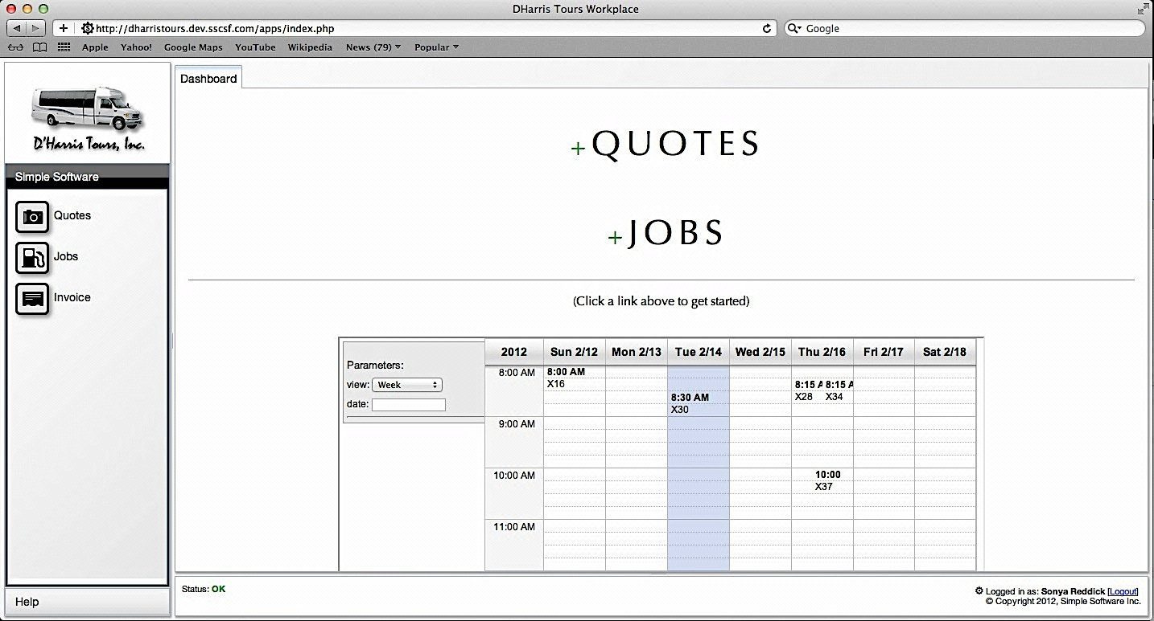

*Calendar Tool Used to Help Customer better plan their Trip Requests*

To the right you will see your Workspace.

1. **Work Area – Dashboard**
2. **Quote Shortcut Button**
3. **Jobs Shortcut Button**
4. **Calendar**
5. **Status Bar**
6. **Change your password**
7. **Logout**

Dashboard

<------------(Business Workspace)------------->

1. **Under Logo – Customer Zone** 
   1. **Customer Zone**
      1. **Request a Quote**
      2. **View Quotes**
      3. **Jobs**
      4. **Invoice**
   2. **Help – Button**
      1. **Report a problem**

*Left Navigation Pane*

**Simple steps to navigate and explore the different components of the screen shot above s listed below**.

### 1 & 2 / Left Navigation layout review

On the left side of the website page is located a D’Harris Tours company logo. The left navigation is under the logo. You will see a few modules and process.

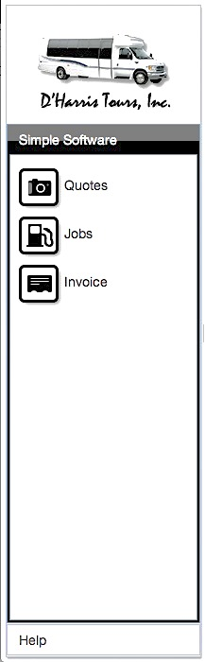

There are two Modules

Tip: *Think of the modules below as a way of grouping similar processes*

1. **Simple Software is a Module**
   1. **There are 4 Processes also known as Buttons**
      1. **Request a Quote**
      2. **View Quotes**
      3. **Jobs**
      4. **Invoice**
2. **Help**
   * 1. **Report a problem**

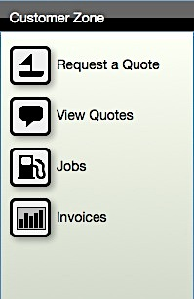

**Module 1**

**Processes/Button’s**

**Module 2**

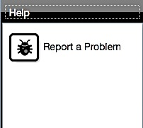

**Processes/Button’s**

(Sometimes referred to as “left navigation pane”)

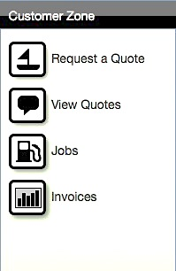A closer look at what’s in our section…

How to request a quote

**

Click on the “Request a Quote” link. A tab will open up to the right of the navigation pane.

**Tabs are**



If you select the process titled “Request a Quote”, a tab will open in your workspace. On the right there will be two tabs open.

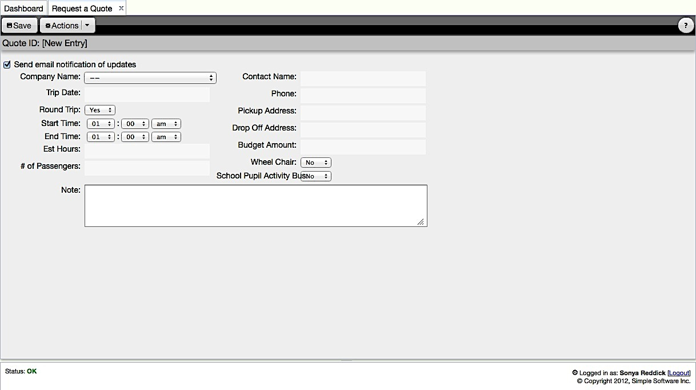The 1st tab reads “Dashboard”. Next to it you will see any other processes you have opened. *The “Request a Quote,” tab will be bold because it is the active process.*

Tabs give you quick access to switch tasks without losing any data. The page is never reloaded!You can switch back and forth just like a desktop application.

**

A new tab will appear “Request a Quote”

Now you may enter all the trip information inside the form under the tab.

**Click SAVE *and you will be automatically updated via***

***e-mail***

D’Harris will 1st update the quote request then notify you via e-mail w/Quote amount.

How to view quotes

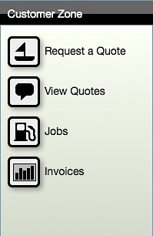

Clicked on the “View Quotes” link a tab will open up to the right of the navigation pane.

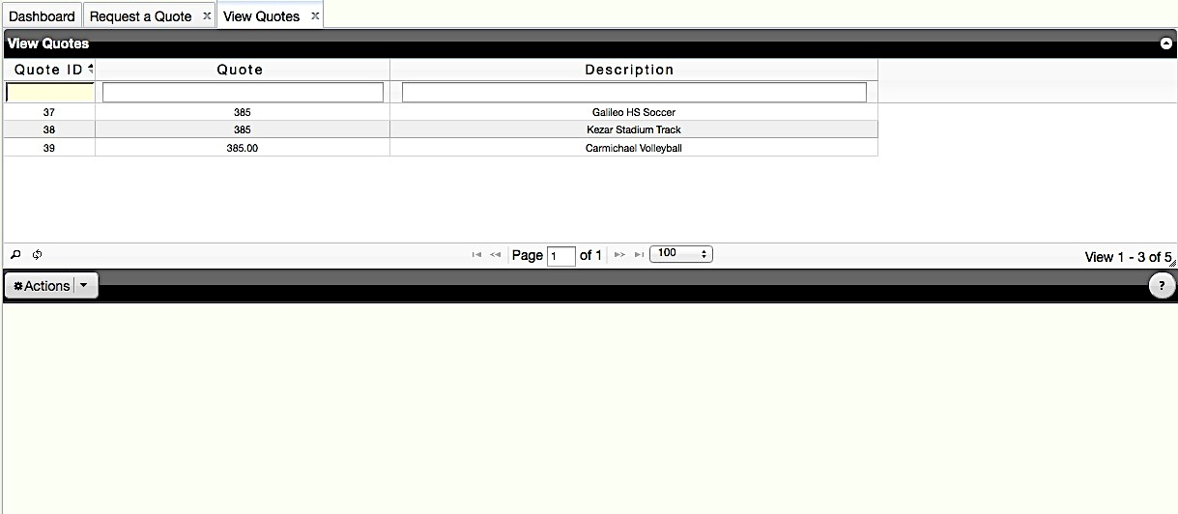

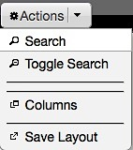

##### The “View Quotes” a tab will open up with a grid under containing all your company’s quotes.

##### Click on the “Toggle Search” button. A search bar will pop up allowing you to customize how you search for a quote, job, or invoice.

##### Click on the “Toggle Search” button again and it will hide the search bar.

**View Next page w/ease!**

Click here to Refresh the Grid

This is an Advanced Search Tool

**

How to view

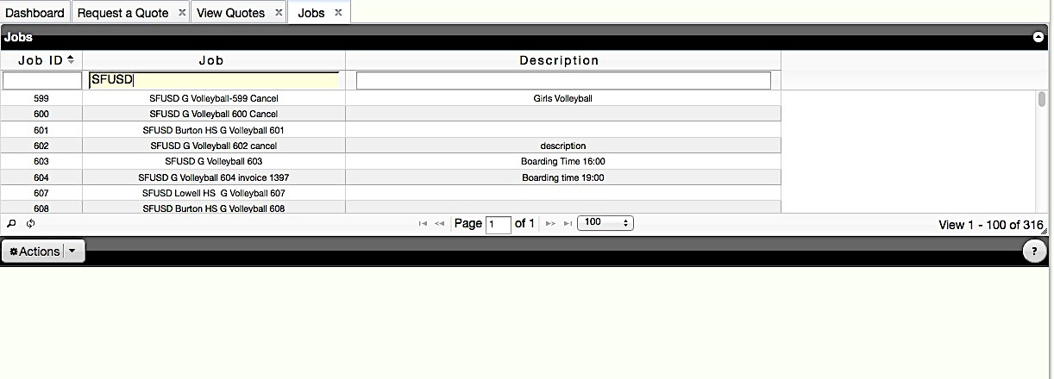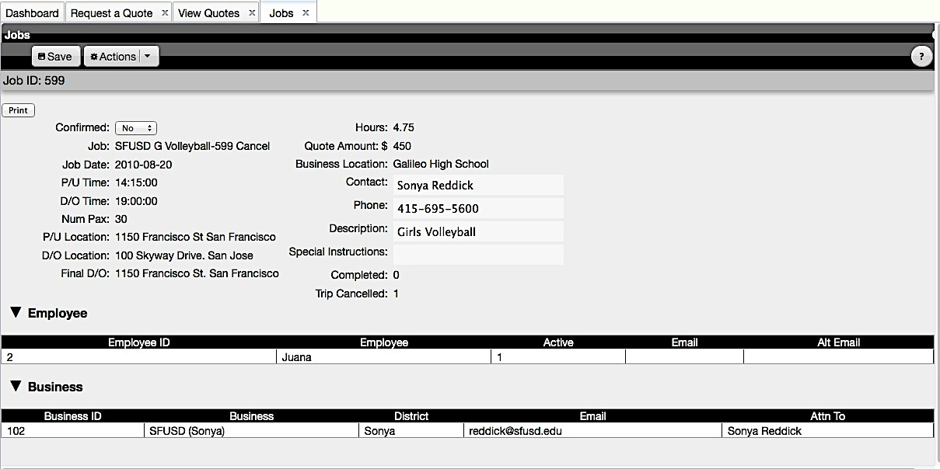How to view

**Click here to view any upcoming or existing jobs!**

**All related information will appear here at the bottom of the form page.**

**Hit print to print job itinerary**

**A tab will open up allowing you to view existing jobs & upcoming jobs**

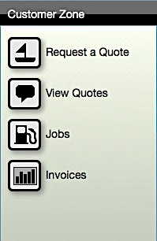

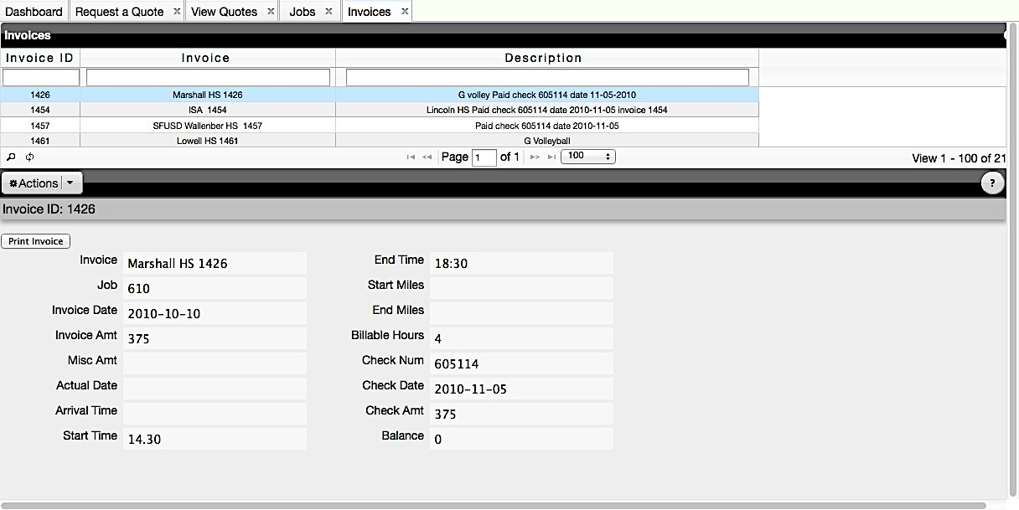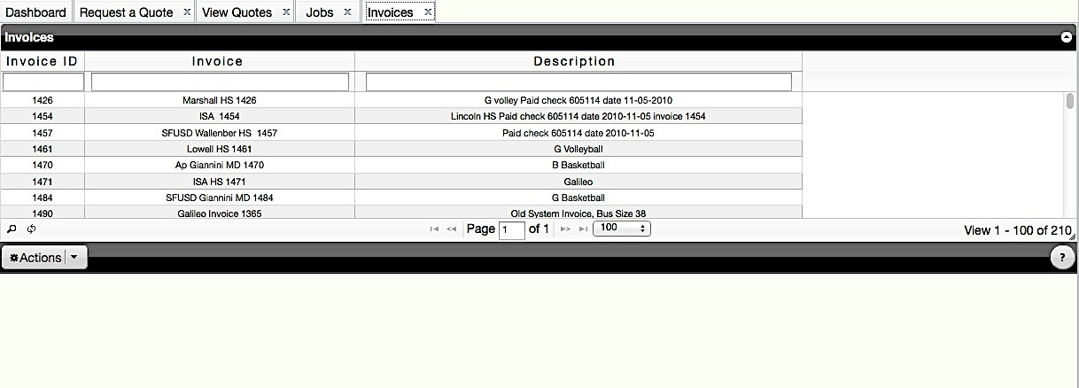

**Select Job and a form will appear below w/Invoice details for Job**

**Hit print to re-print your Invoice**

1. *Dashboard and Tabs*
   1. *Locate shortcut buttons*
   2. *How to view the calendar*
   3. *Understand what the status bar does, how to change your password and log out*

Overview of Dashboard shortcut buttons

Dashboard

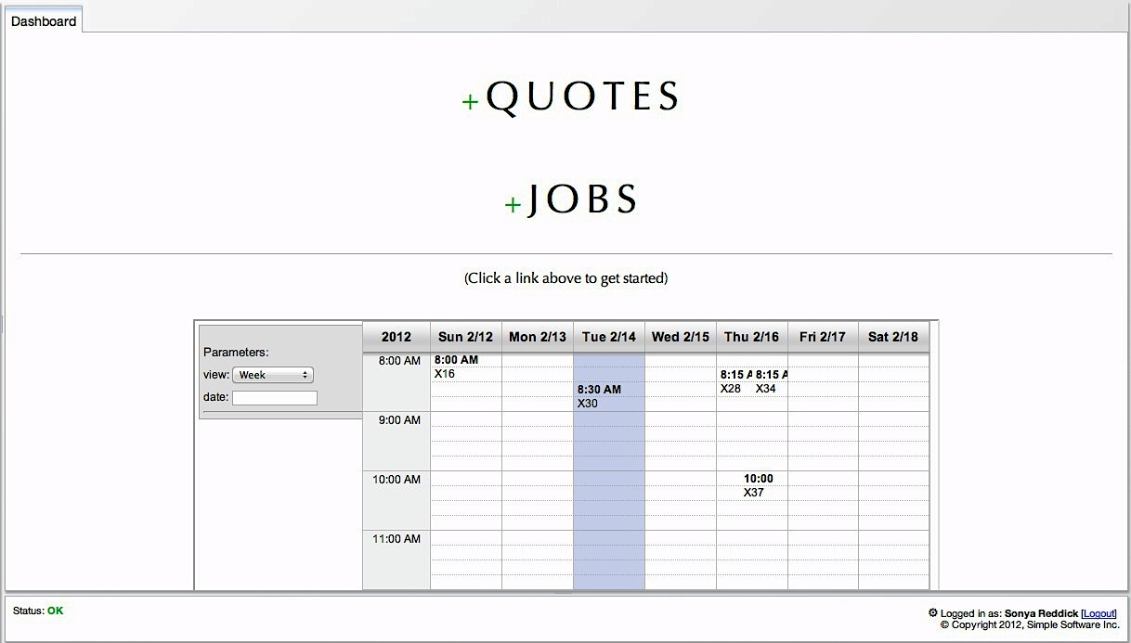

**To the right of the “Navigation Pane” is your “Dashboard”. *There are a 2 buttons that are shortcuts****.*

***1st shortcut***

***2nd shortcut***

***1st shortcut***

**+ Quote -**

**To add a new quote (job) click “+ Quote”.**

***2nd shortcut***

**+ Jobs -**

**Click here to view or confirm jobs.**

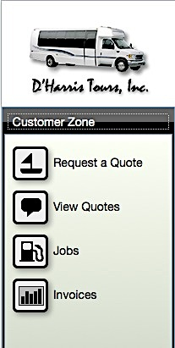The 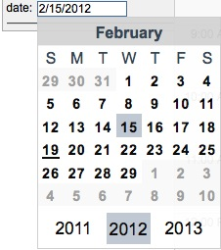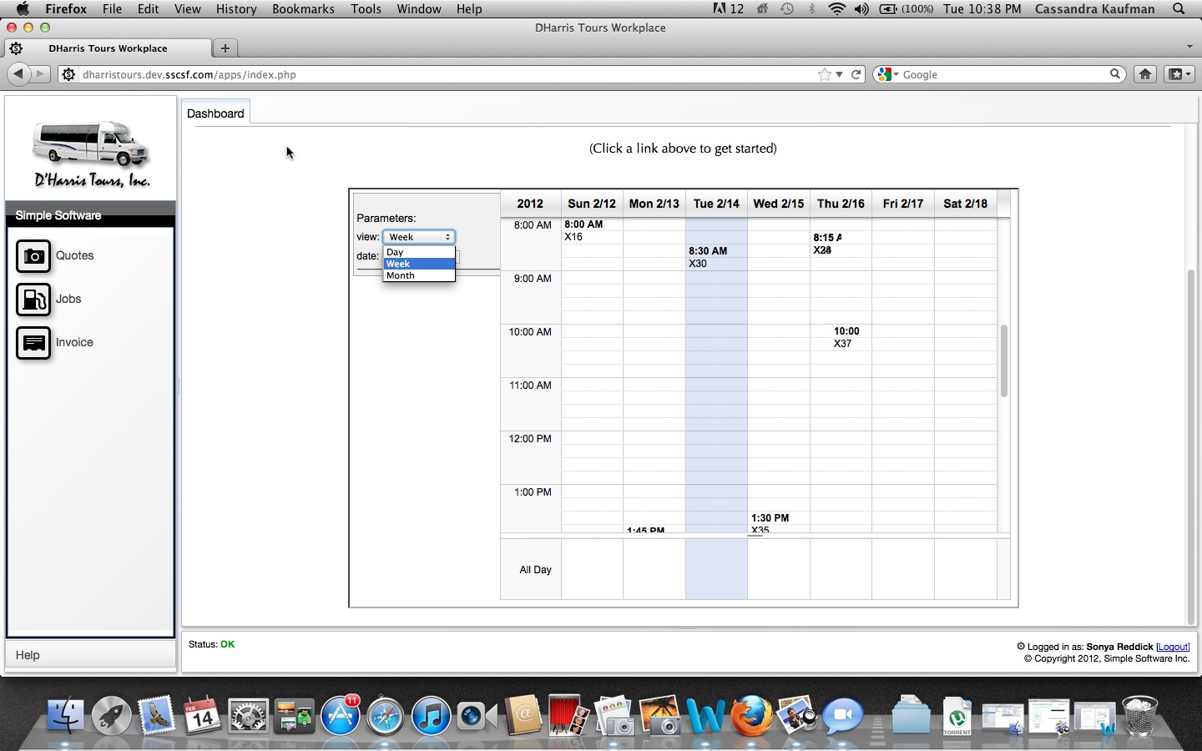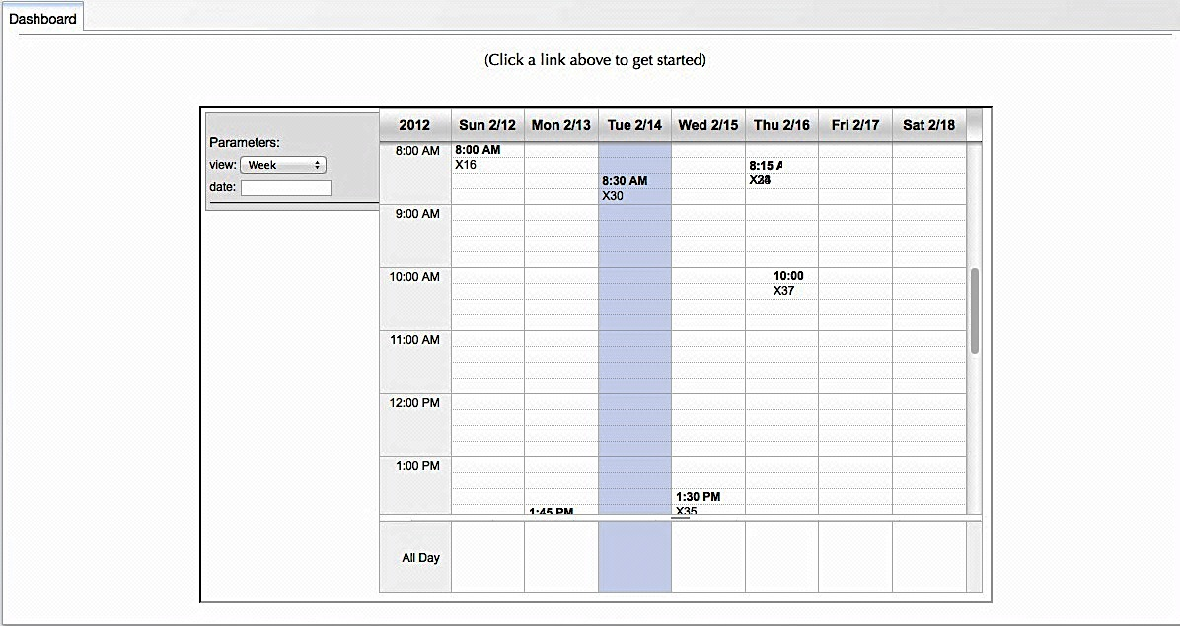

Remember to use the shortcuts

***1st shortcut 🡪 + Quote***

**This is used to add a new quote (job).**

* This is a shortcut for “Request a Quote” button located under the “Customer Zone” section.

***2nd shortcut🡪* + Jobs**

**This shortcut is used when wanting to view existing jobs or when wanting to confirm jobs.**

**\*** This is a shortcut for the “Jobs” button located under the “Customer Zone” section.

##### Click on the type of calendar view desired.

* **Or enter in a specific job date**

##### Here you’re able to see all daily, weekly, and monthly jobs

##### This tool can be used to help better assess future job requests and check availability quickly!

**Dashboard Calendar View**

**Lets take a closer look: Your dashboard is your work area**

To the bottom of the screen under your work area, you will see a “Logged in as” & a “Status” box.

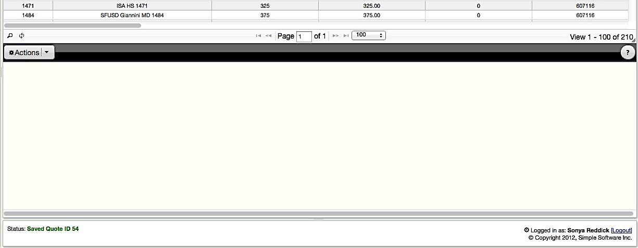

The status bar provides information such as:

* system status
* add, delete, update, relate to records
* person that is currently logged in

*The Status will be highlighted in green, alerting you of changes with work done in your workspace.*



*.*

The ‘gear’ symbol allows you to change your password.



One you click on the symbol above the “Change Password” dialogue will appear.

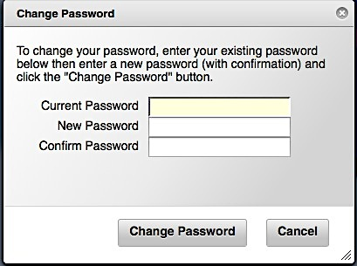

then…



After you change your password, you must log out and then log back in.